12.17: a) See Exercise 12.16;

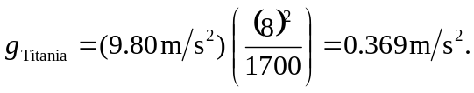

b)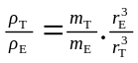, or rearranging and solving for density, 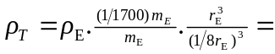
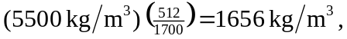 or about 